

**ECET 400: Senior Project**

**Concept and Functional Specifications**

**Title Project: Automatic Rear-View Mirror**

**Professor:**

**Alex Blinder**

**Students:**

**Valentina Clavijo**

**Diego Andrade**

**Kyuung (Casey) Cha**

**Nigel Ng**

**Mohammad Rahman**

**Date: 10/07/24**

‘

**Table of Contents**

1.0 Introduction 6

1.1 Biography Team Members 8

1.1.1 Valentina Clavijo Zuluaga 8

1.1.2 Diego Andrade 9

1.1.3 Kyuung (Casey) Cha 10

1.1.4 Nigel Ng 10

1.1.5 Mohammad Rahman 11

2.0 Project Organization 12

2.1 Industrial Support 13

3.0 Concept 13

4.0 Functional Specifications 16

4.1 General Requirements: 17

● 4.1.1 Product features: 17

● 4.1.2 Physical layout 18

● 4.1.3 Power: 18

● 4.1.4 User Interface: 19

● 4.1.5 Max cost per unit: 20

4. 2 Interfacing Requirements Description: 20

● 4.2.1 Peripherals for Visual Displays: 20

● 4.2.2 Peripherals for User Input: 20

● 4.2.3 Interfacing with other equipment: 21

5.0 Research 22

5. 1 Automatic Adjustable Rear-View Mirror Using Servo Motor and Arduino for Bikes 22

5. 2 Automatically Adjustable Rear Mirror Based On Computer Vision 23

5.3 The Economic and Societal Impact of Motor Vehicle Crashes, 2019 24

5.4 Car Crashes, Innovation, and Why Federal Policy Should prioritize Adoption of Existing Technologies to Save Lives 25

5.5 ACS 5-Year Estimates Data Profiles: 2018-2022 for Household Characteristics, 2022 26

5.6 Factors Affecting Lane Change Crashes 27

5.7 Car Ownership Statistics 2024 28

5.8 Active Ball Joint Mechanism For Rear View Mirror 28

5.9 How Mirror Settings Is Crucial for Safe Driving 30

5.10 Mouse cursor control with eye movement using OpenCV and machine learning 31

6.0 Hardware 32

7.0 Software 35

8.0 Project Plan 36

8.1 Gantt Chart 36

8.1.1 Purpose 36

8.1.2 Key components 37

8.1.3 Advantage 37

8.1.4 Template 37

8.2 Work Breakdown Structure 39

8.3 Four Hardware/Software Deliverables 40

8.4 Possible Problems 40

8.4.1 Compatibility Issue with camera, microcontroller, and the motor 40

8.4.2 Software not being able to detect coordinates properly due to interference 41

9.0 Appendices 41

9.1 Acronyms and Definitions 41

9.2 Parts list 42

References 44

**List of Figures**

**Figure 1: Eye-tracking. 6**

**Figure 2: Functional Specifications Diagram 16**

**Figure 3: Physical Layout 17**

**Figure 4: Automatic Adjustable Rear-View Mirror 21**

**Figure 5: Automatically Adjustable Rear Mirror 22**

**Figure 6: Economic Costs of Police-Reported-Identified Distraction Crashes 23**

**Figure 7: Comprehensive Costs of Police-Reported-Identified Distraction Crashes 24**

**Figure 8: Car Household Statistics 25**

**Figure 9: Prototype** **28**

**Figure 10: Gears in a ABENICS** **28**

**Figure 11: Distance perceived correlation 29**

**Figure 12: Eye Movement Mouse Cursor Project Flowchart 30**

**Figure 13: Top Level Block Diagram 31**

**Figure 14: 2nd Level Block Diagram 32**

**Figure 15: Flow chart (Software) 34**

**Figure 16: Gantt Chart Automatic Rear-View Mirror 37**

# **1.0 Introduction**

With the increasing popularity of car-sharing services such as Zipcar and Enterprise CarShare, a new era of shared vehicle usage is emerging. According to Allied Market Research, the demand for car-sharing is on the rise[1]. This shift is also reflected in the findings of the National Household Travel Survey, which reports that the average car per household remains below 2.0[2]. As a result, a growing number of drivers are relying on shared vehicles rather than owning their own cars. Shared vehicles offer flexibility but also come with unique challenges due to the high turnover of users within short intervals.

Unlike privately owned vehicles, where a single driver typically adjusts the mirrors to their preference and rarely changes the settings, shared cars are used by multiple drivers in quick succession. This frequent rotation necessitates manual mirror adjustments before each drive, which can become tedious and prone to oversight. Without proper mirror adjustment, drivers risk reduced visibility, leading to dangerous blind spots and potential accidents. This recurring issue highlights the importance of finding a reliable solution to ensure mirrors are properly aligned for every driver using a shared vehicle.

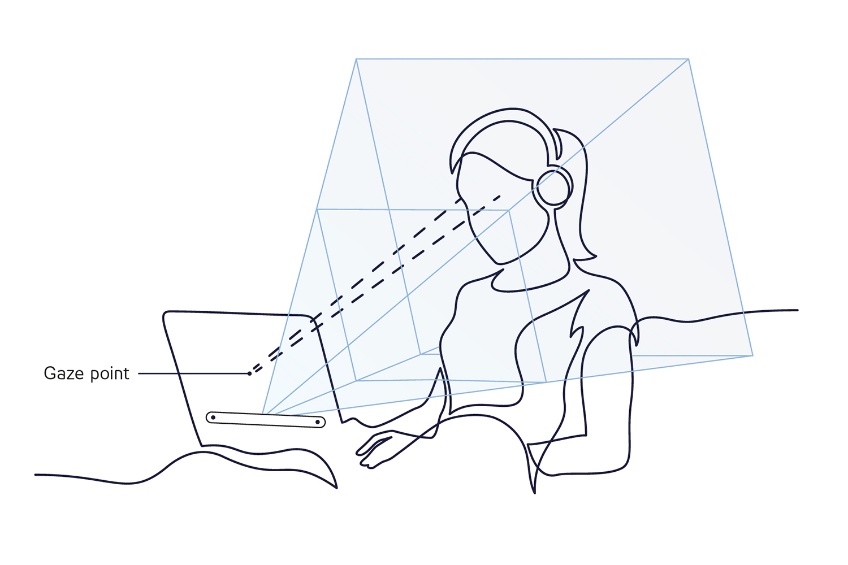

*Figure 1: Eye-tracking.*

Figure 1 shows a basic representation of how eye-tracking uses the positions of the eye to detect exactly where the line of sight is. This is the basic principle that the project will utilize to complete the prototype. Eye-tracking precision will be determined on the camera that will be utilized and the code implemented

## 

## **1.1 Biography Team Members**

### **1.1.1 Valentina Clavijo Zuluaga**



Born in Colombia, Valentina Clavijo studied for two years at Technological University of Pereira following a bachelor's degree in Mechatronics Engineering and acquired a technical degree in Mechatronics. She moved to the United States in 2021 and decided to continue her education at NJIT in 2022. She chose a bachelor’s degree in electrical and computer engineering technology, where she has gained interest in control systems, automation, robotics, and power systems. Following her passion, she applied for a position at PSE&G as an electric operations technical intern.

### **1.1.2 Diego Andrade**



Born and raised in Ecuador until the age of 10, moved to the United States and started a new life. Started college at New Jersey Institute of technology in 2020 right after graduating and the covid-19 pandemic hit. Pursued a engineering degree in Electrical and Computer Engineering Technology and it turned into a passion of power generation and distribution which was sought out at Public Service Electric and Gas. Started working as an electrical operations intern at PSE&G in the summer of 2023 where power systems, looped systems, and generation stations were learned.

### **1.1.3 Kyuung (Casey) Cha**



Kyuung Cha - or goes by Casey - is a South Korean software developer who recently retired from the Korean military. He moved to New Jersey with his diplomatic parents in 2016 and decided to pursue his engineering dream in America.

### **1.1.4 Nigel Ng**



An American-born Chinese Test Engineer with aspirations to become an engineer who works with renewable energy and travels the world. Began studying at NJIT after transferring from ECC, and has been working as a Test Engineer for Cygnus LLC.

### **1.1.5 Mohammad Rahman**



Born and raised in Kuwait moved during his high school year back in 2016. He always aspired to be an engineer. Although he decided to be a mechanical engineer at first he switched to ECET as he had interest in electronics and embedded systems and also to gain more hands-on experience.

# 

# **2.0 Project Organization**

Table #1: Project Responsibilities

| **Name** | **Responsibility** |
| --- | --- |
| Casey | Research, Software |
| Mohammad | Research, Software Assist |
| Diego | Research, Circuit Verification, Monitor Progress |
| Nigel | Research, Circuit Verification, Hardware |
| Valentina | Research, Circuit Verification, Test Validation |

**Software**: In charge of writing the code and checking it over making sure it works.

**Software Assist**: In charge of assisting the software lead to double check and confirm that code works, as well as troubleshooting.

**Monitor Progress**: Team lead making sure that all members of the team perform their part and are consistently contributing to the project.

**Circuit Verification**: In charge of creating the circuit construction for the product, as well as troubleshooting the wiring for the components.

**Research**: Each team member is responsible for researching articles and studies to support the basis of the project to prove its viability.

**Hardware**: In charge of the physical components testing and troubleshooting as well as assembling the housing unit.

**Test Validation**: In charge of troubleshooting both physical and software components to make sure they work.

## **2.1 Industrial Support**

No industrial support was offered or provided from outside sources for the project, the majority of the costs for the project would be at the expense of each individual group member. Everything from the Raspberry Pi to the camera, to the individual parts used to create the housing unit, was paid for and made by the members of the project group.

# **3.0 Concept**

Title: Automatic Rear-View Mirror

One of the major safety concerns in shared vehicles is the inconsistent or incorrect adjustment of mirrors, leading to improper visibility and potential blind spots. According to the National Highway Traffic Safety Administration, more than 800,000 accidents occur annually due to blind spot issues, with 300 of these resulting in fatalities[3]. The need for manual adjustment of mirrors by multiple users can lead to negligence or inaccurate positioning, significantly compromising road safety. To mitigate this issue, there is a growing demand for technological solutions that ensure consistent and accurate mirror adjustments for every driver, without requiring manual input.

One promising solution to this problem is the Eye-Tracking Automatic Adjustment Rear-View Mirror, which adjusts mirrors according to the driver’s line of sight before they begin driving. This system integrates a driver-facing camera and a motorized ball joint to provide precise mirror positioning based on the driver's eye movements. When the vehicle is started, the camera detects the driver’s presence and tracks their pupil coordinates to calculate the optimal alignment for the rear-view mirror. If the driver attempts to drive before the adjustment process is completed, an LED light alerts them to wait. Once the pupil coordinates are captured, the system determines the necessary adjustment angle and sends this information to the motorized ball joint, which adjusts the mirror to the optimal position, ensuring clear rear visibility. The mount for the ball joint is a custom-made, universal component designed to fit any vehicle, offering a one-size-fits-all solution that can be easily installed across different car models.

A study conducted by the Tongmyong University Industrial-Academic Cooperation Foundation (2020) explored the potential of eye-tracking technology for rear-view mirror adjustment, highlighting its benefits for enhancing driver safety and addressing issues such as blind spots and improper mirror alignment. However, there are few things that sets this project apart from the study.

Table #2: Originality Comparison Table

| **Description** | [Tongmyong University](https://worldwide.espacenet.com/publicationDetails/biblio?CC=KR&NR=102135305B1&KC=B1&FT=D&ND=&date=20200717&DB=EPODOC&locale=) | [Automatic rearview mirror adjustment system for vehicle](https://patents.google.com/patent/US20100017071A1/en) | Automatic Rear-View Mirror |
| --- | --- | --- | --- |
| **Features** | * Automatic Rear-View mirror adjustment through Camera and Head - Car Ceiling distance | * Automatic Rear-View and Side-View mirror adjustment based on first manual adjustment. | * Eye tracking automatic adjustment * Automatic & Powered Mode * Pre-adjustment alert safety indiciation |
| **Control** | * Automatic | * Manual through joystick first then automatic | * Automatic * Powered Rear-View Mirror |
| **Hardware** | * Camera * Head - Car Ceiling distance measuring sensor | * Joystick | * Camera * DC motors * D-pad * Buttons * Abenics Gear Joint * Pilot Light |
| **Software** | * Calculates the optimal angle of sight | * Stores the previously adjusted angle for reuse | * Camera Point Alignment |
| **Accessibility** | * Built in | | * Replaceable |
| **Percent Originality** | | | 60% |

This project introduces an original solution, with approximately 60% of its design being innovative, building on the foundational research and transforming the concept into a practical, market-ready system. Unlike the previous study, the Eye-Tracking Automatic Rear-view Mirror Adjustment System is a fully developed product designed to meet real-world needs where consistent mirror adjustments are crucial for safety.

# **4.0 Functional Specifications**

Rear-view mirrors, side-view mirrors, seat adjustment, and seat belts are what drivers are required to check every time before they go out on the open road. These are the safety checks drivers must perform any time when getting in a vehicle whether it is due to shared-driving or frequent adjustments made to the driver’s car seat. Side-view mirrors and seat position is now adjusted depending on the key where the seat position is saved inside the key. According to the National Highway Traffic Safety Administration[4] (NHTSA) crashes involving a distracted driver account for 14% of all crashes in the United States, costing the economy a little over $46 billion. Some of these distractions involved cell phone use, talking to other passengers, adjusting mirrors/radio, eating/drinking, diverting attention from the road, or being lost in thought. Consumer reports[5] expects innovative technologies to save more lives if implemented in all vehicles. To eliminate the distraction of adjusting mirrors, save the economy millions of dollars, save lives, and/or stop accidents a new solution must be sought. To solve this safety problem, an automatic rear-view mirror that can be implemented using already available technology is the goal. Automatic mirrors can help avoid more collisions by making sure rear-view mirrors give the best view of the driver's surroundings.

Using eye tracking technology that correctly detects and locates the position of the driver's eye. Based on the position of the eyes and the position of the rear windshield, the software will try to align itself based on those inputs. Because the rotation and joint system uses the ABENICS[6] joint it will have full control over the x and y axis and allow for an axial tilt rotation. Based on these parameters, the rear-view mirror will not need adjustment via user input. If the automatic feature does not function properly, the product will also include a powered adjustment that will use the directional pad that most vehicles use to adjust their powered side-view mirrors.

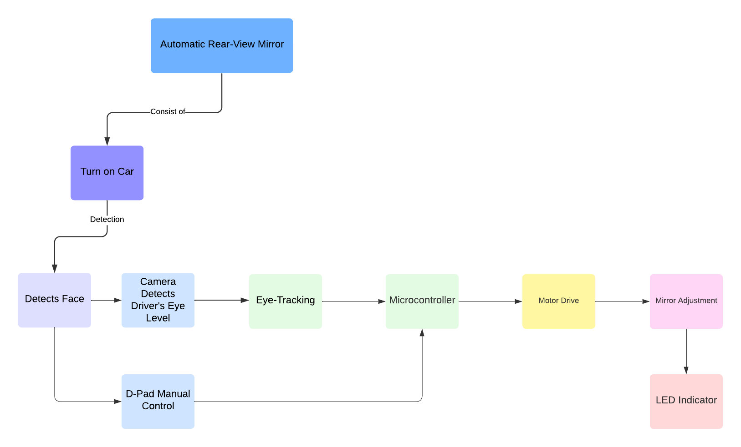

*Figure 2: Functional Specifications Flowchart*

## **4.1 General Requirements:**

### **4.1.1 Product features:**

* + Automatically Adjust mirror:
    - Eye tracking technology will automatically adjust the mirror based on the driver's position.
  + Switch modes:
    - The driver can choose to turn off the automatic feature or switch to manual if the camera fails to work.
  + D-pad adjustment:
    - Powered mirror adjustment based on the user's input.
  + Visible alert:
    - Warning light will be displayed so the driver is aware of automatic adjustment.

### **4.1.2 Physical layout**

* Webcam will be attached to a traditional mirror.
* Ball joint will attach to the mirror.
* Ball joint, motors, and cabling will be hidden by a plate cover.
* Raspberry pi will be placed inside the cover.
* D-pad to be on the door panel.

### **4.1.3 Power:**

* + Onboard power:
    - Ideal prototype will use onboard power as any electrical component inside the vehicle.
  + Battery powered.
    - Prototype will need a battery to power the motor as it requires between 9 to 12 volts.
  + Outlet Power:
    - Prototype will be plugged into the wall to power raspberry pi components.

### **4.1.4 User Interface:**

* + Automatic Mirror Movement:
    - Driver’s eyes position will determine adjustment.
  + Powered Mirror Control:
    - D-pad for user input to adjust the mirror in the x and y axis.
  + LED indicator:
    - LED indicator to warn driver of automatic adjustment commencing.
  + Power Button:
    - Serves as the power button for the prototype.
    - Serves as the reset button for automatic adjustment.
  + Camera:
    - Camera to be built into the mirror and requiring no user interaction.

### **4.1.5 Max cost per unit:**

Table #3: Max Cost Per Unit

| **Items** | **Part Number** | **Quantity** | **Cost Per Unit** | **Total Cost** |
| --- | --- | --- | --- | --- |
| Raspberry Pi | 4 model B | 1 | $60 | $60 |
| Motors | DC 12V 550 RPM | 2 | $25 | $50 |
| Directional Pad | Joystick Raspberry Pi | 1 | $30 | $30 |
| Abenics Ball Joint | N/A | 1 | $1 | $1 |
| Pilot Light | 3mm LED Light | 1 | $1 | $1 |
| Camera | RPI-CAM-V2 | 1 | $30 | $30 |
| Breadboard | 7545924028 | 1 | $15 | $15 |
| Rear-View Mirror | BT-4MG9-2IM9 | 1 | $20 | $20 |
| Wires | EL-CP-004 | 1 | $10 | $10 |
| **Total Cost** | | | | $217 |

* **4.1.6 Software:**
  + Pupil / face detection with coordinate calculations algorithms.
  + Motor control system.

## **4. 2 Interfacing Requirements Description:**

### **4.2.1 Peripherals for Visual Displays:**

* + Potential use of smart dashboards to implement personal settings for different drivers.
  + Potential use of a smart dashboard for user inputs.

### **4.2.2 Peripherals for User Input:**

* + LED indicator:
    - LED indicator to warn driver of automatic adjustment commencing.
  + Power Button:
    - Serves as the power button for the prototype.
    - Serves as the reset button for automatic adjustment.
  + Mode Switch Button:
    - Button that allows the user to toggle between automatic and powered mirror mode.
  + Camera:
    - Camera to be built into the mirror and requiring no user interaction.

### **4.2.3 Interfacing with other equipment:**

* + Potential use of seat sensors to confirm when the driver is positioned to do automatic adjustment.

# **5.0 Research**

## **5. 1 Automatic Adjustable Rear-View Mirror Using Servo Motor and Arduino for Bikes**

Different technologies have been developed and implemented to solve real problems. Automatic Adjustable Rear-View Mirror (AARM) has been developed using an arduino microcontroller and servo motors. It is a safety solution for bikes to automatically adjust rear-view mirrors without manual intervention. The structure implements an arduino microcontroller that can process the information from the inputs and calculate the angles to adjust the position of the mirror based on data collected from real time, servo motor receives the commands from Arduino microcontroller and converts the commands into rotational movement, and linkage system that converts the rotational movement into linear movement to allow the adjustment of the rear view mirror position.

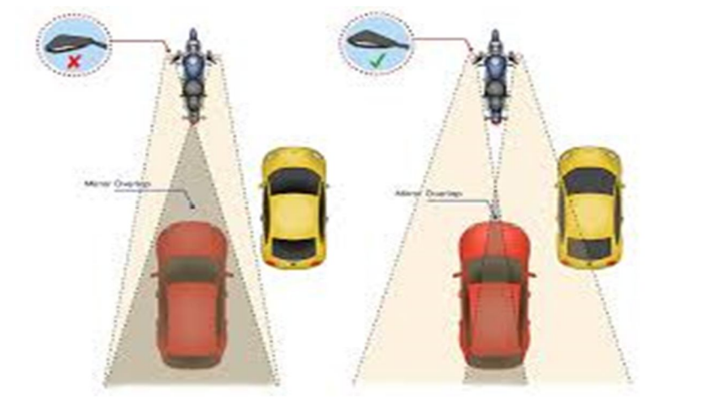

*Figure 4: Automatic Adjustable Rear-View Mirror Using Servo Motor and Arduino for Bikes (Karvir, 2023)*

**Reference**

Karvir, S. (2023). Automatic Adjustable Rear-View Mirror Using Servo Motor and Arduino for Bikes. *International Journal for Research in Applied Science and Engineering Technology*. <https://doi.org/10.22214/ijraset.2023.57169>.

## **5. 2 Automatically Adjustable Rear Mirror Based On Computer Vision**

This document is about a rear-view mirror that can be adjusted automatically based on computer vision. The purpose of this project is to increase safety systems inside a car allowing that the rear view mirror can adjust without intervention of the driver. The driver can see the rear of the car without movement of the head. The camera scans the inside of the car, detecting the face of the driver and sending the picture of the driver to the system that implements OpenCV to calculate a 3D vector from a point of reference to the face detected. It measures the position of the person and adjusts the mirror automatically by motors. The key components of that project are a camera, microcontroller, servo motor and rear view mirror. One difficult present in this project is the detection of the face in different lighting conditions.

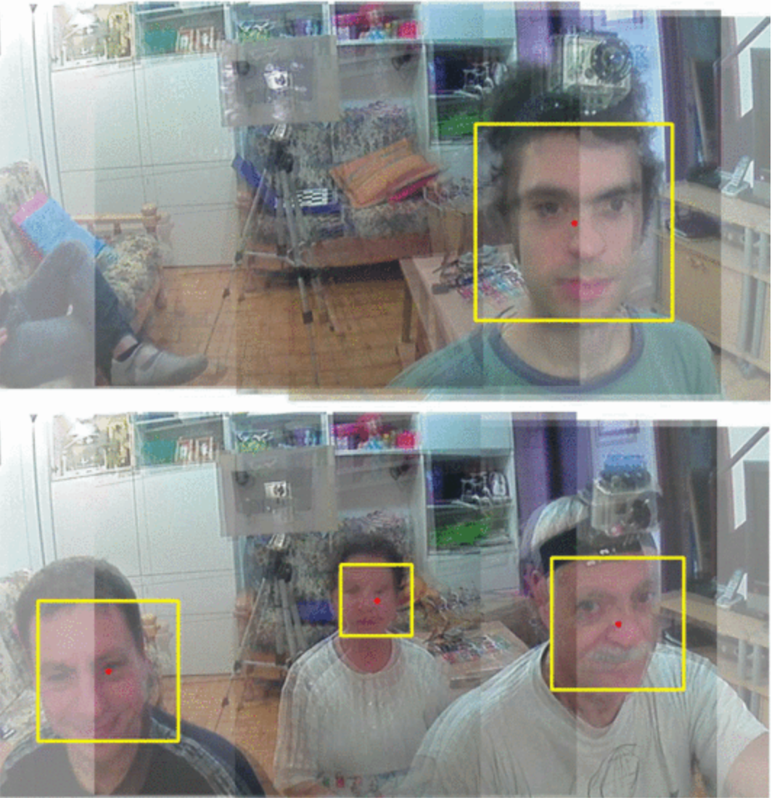

*Figure 5: Automatically Adjustable Rear Mirror Based on Computer Vision (Rota, F., & Stefano, L, 2017)*

**Reference**

Rota, F., & Stefano, L. (2017). Automatically adjustable rear mirror based on computer vision. *2017 International Conference of Electrical and Electronic Technologies for Automotive*, 1-7. <https://doi.org/10.23919/eeta.2017.7993218>.

## **5.3 The Economic and Societal Impact of Motor Vehicle Crashes, 2019**

Distraction whether it is inside or outside, and inattention, was involved in about 17.7 % of all cases where these factors attributed to crashes. Types of distractions include drivers using their cell phone, adjusting their mirrors or radios, eating or drinking, diverting attention away from the road, or being lost in thought. In 2019 about 9% of crashes that ended in a death and 15% of crashes with injuries were reported as distraction-affected crashes. 3,142 people were killed involving distracted drivers and 424,000 were injured in police-reported motor vehicle crashes. 13% of distracted drivers involved in a fatality and 7% of injured people in distraction affected crashes involved the use of cell phones. Crashes involving distracted drivers had a cost of $46 billion on the Economy in 2019.

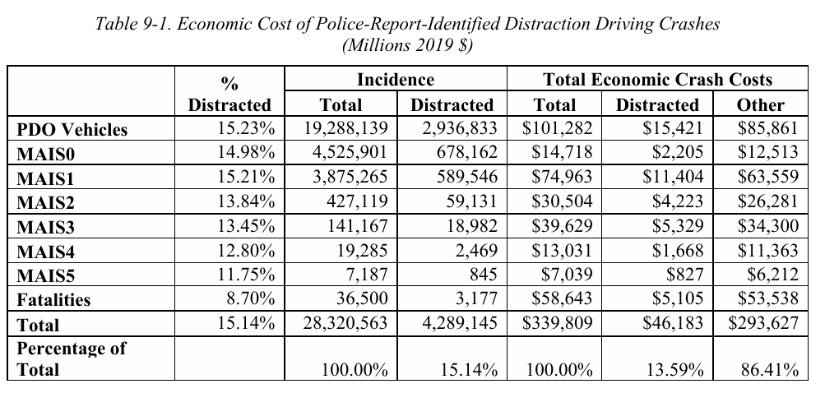

*Figure 6: Economic Costs of Police-Reported-Identified Distraction Crashes*

In 2019 crashes involving distracted drivers contributed to $170 billion in societal harm as measured by comprehensive costs, roughly 12 percent of total harm caused by motor vehicles.

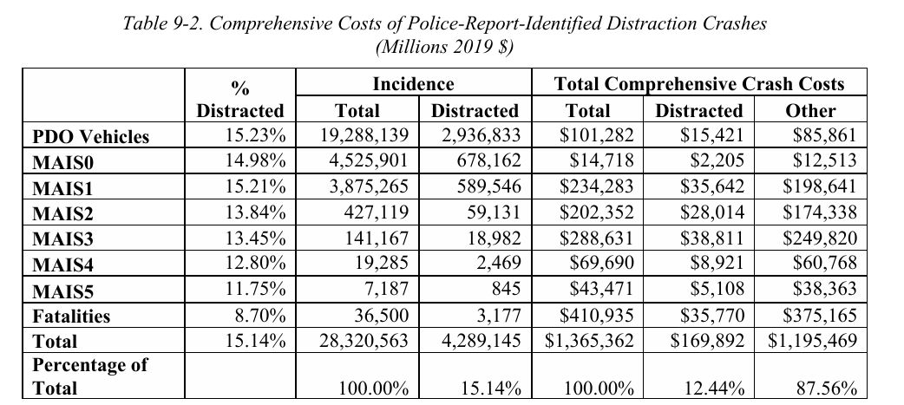

*Figure 7: Comprehensive Costs of Police-Reported-Identified Distraction Crashes*

**Reference**

Blincoe, L., Miller, T., Wang, J.-S., Swedler, D., Coughlin, T., Lawrence, B., Guo, F., Klauer, S., & Dingus, T. (2023, February). *The economic and societal impact of motor vehicle crashes, 2019 (Revised)* (Report No. DOT HS 813 403). National Highway Traffic Safety Administration. [The Economic and Societal Impact of Motor Vehicle Crashes, 2019 (Revised) (dot.gov)](https://crashstats.nhtsa.dot.gov/Api/Public/ViewPublication/813403.pdf)

## **5.4 Car Crashes, Innovation, and Why Federal Policy Should prioritize Adoption of Existing Technologies to Save Lives**

The focus of this research paper is to convince policymakers to require all vehicle manufacturers to implement car safety features that already exist. Currently available technologies like automatic emergency braking (AEB), lane departure warning (LDW), blind spot warning (BSW), and pedestrian detection technologies could reduce 11,800 or more fatalities a year. Drunk driving prevention technology, the Driver alcohol Detection System for Safety (DADSS), could save around 5000 lives in a year. All these types of technologies could save around 20,000 lives per year due to their effectiveness.

**Reference**

Safety first: car crashes, innovation, and why federal policy should prioritize adoption of existing technologies to save lives - CR Advocacy. (2020, June 28). CR Advocacy. <https://advocacy.consumerreports.org/research/cr-safety-first-car-crashes-innovation-federal-policy-study/>

## **5.5 ACS 5-Year Estimates Data Profiles: 2018-2022 for Household Characteristics, 2022**

This data sheet from the U.S. Census Bureau highlights the characteristics of homes based on a sample of homes throughout the United States. Namely, under the vehicles available section, out of the 125,736,353 occupied housing units throughout the U.S. 32.6% of homes have at the very least one vehicle available. Compared to 8.3% of housing units that have no vehicles available, as well as the 37.0% and 22.1% of housing units that have 2 and 3 or more vehicles available respectively.

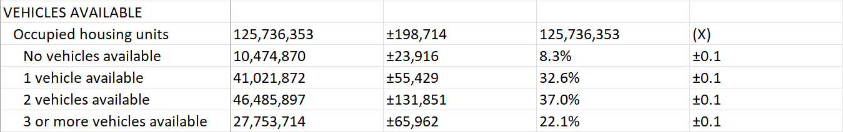

*Figure 8: Car Household Statistics*

**Survey/Program**: American Community Survey **Year**: 2022 **Estimates**: 5-Year   
**Table ID**: DP04 **Source**: [U.S. Census Bureau, 2018-2022 American Community Survey 5-Year Estimates](https://data.census.gov/table/ACSDP5Y2022.DP04?moe=true)

## **5.6 Factors Affecting Lane Change Crashes**

This study by Mohamed Shawky focuses on the multiple factors that correlate and occur before crashes happen during a lane-change maneuver by drivers. The two data sets collected were from traffic police reports and a questionnaire survey asked to 429 drivers. The statistical attribute variable for crash occurrence during a lane change included ‘the drivers’ characteristics (gender, nationality, and years of experience in driving), location and surrounding condition factors(non-junction locations, light and road surface conditions) and road features (road type, number of lanes and speed limit value).[7] The author also made mention of other sources of distractions that caused the quick lane change, including to mention how 21.6% due to being distracted by a mobile device. Drivers who make quick and sudden lane changes are 2.53 times more likely to cause or be involved in a traffic accident, contrasted to those who check their mirrors and look out their windows before a proper lane change at 4.61 and 3.85 times respectively.

**Reference:**

M. Shawky (2020), "Factors affecting lane change crashes", IATSS Res., vol. 44, no. 2, pp. 155-161, Jul. 2020. <https://www.sciencedirect.com/science/article/pii/S0386111219300020>

## 

## **5.7 Car Ownership Statistics 2024**

This article focuses on the car ownership statistics for the U.S. in a five year period from 2018 to 2022 for personal and commercial vehicle registration. The focal points of topics that were mentioned within the article include the estimated total number of cars within the U.S., car ownership by state and metropolitan area, and how much does it cost to own a car. The current estimated total of registered personal and commercial vehicles as of 2022 is 278.9 million, with an upward trend increase of 3.5% since 2018 at 269.4 million. Including, the staggering increase in costs to own a motor vehicle at a 13.6% from 2022 where the average yearly cost was $10,728, or $894 a month, to now costing vehicle owners $12,182 a year, or $1015 a month[8].

**Reference:**

Valentine, Ashlee (2024); Smith, Kelly Anne (2024). Car Ownership Statistics 2024**,**

Forbes Advisor, March 2024. <https://www.forbes.com/advisor/car-insurance/car-ownership-statistics/>

## **5.8 Active Ball Joint Mechanism For Rear View Mirror**

ABENICS (active ball joint mechanism) is a type of gear-based joint that has multiple degrees of freedom just like the ball and socket joint. However, it can eliminate slippage and provide higher torque and better transmission. It uses two gears called the cross spherical gear and monopole gear which interact with each other along with a non-slip gear meshing resulting in a higher torque. This kind of technology may help in making a more robust and adjustable rear-view mirror. It has also shown to reduce energy and resource consumption.

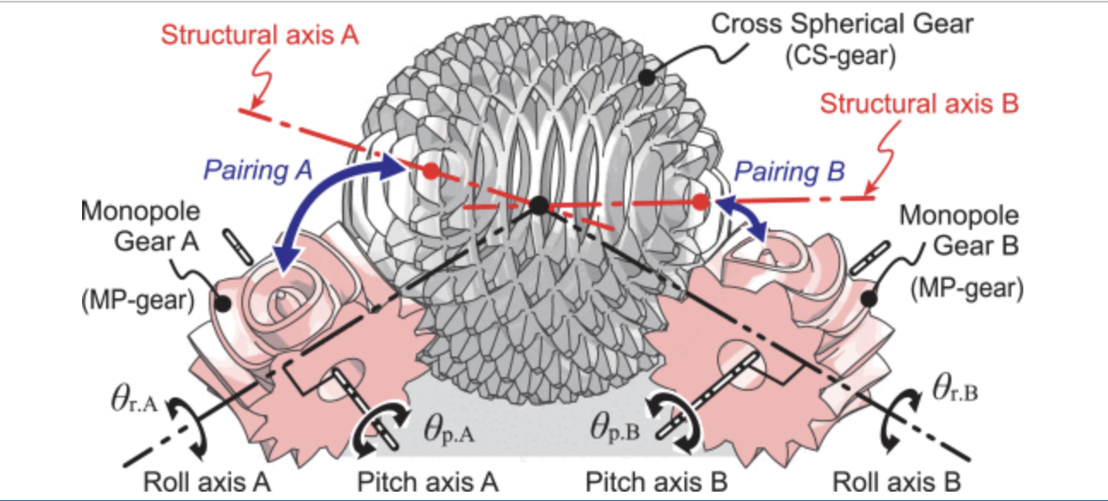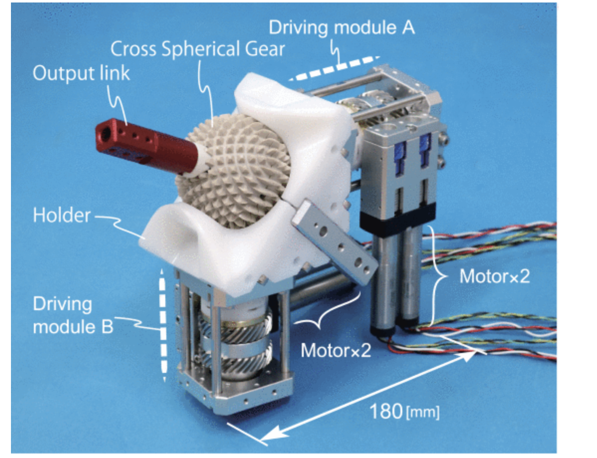

*Figure 10: Gears in a ABENICS* 

**Reference**

Zhang, Wei, et al. "ABENICS: Active Ball Joint Mechanism With Three-DoF Based on Spherical Gear Meshings." *IEEE Journals & Magazine*, IEEE Xplore, 2023, https://doi.org/10.1109/JOURNAL.2023.

## 

## **5.9 How Mirror Settings Is Crucial for Safe Driving**

A study showed that mirror settings play a crucial role in safe driving and the way people set their mirror can affect perceived distances resulting in unsafe lane changes. In the United States lane change caused about 9 percent of the total traffic accidents. The study used two types of mirror adjustments, vertical and horizontal. Different adjustments were tested, vertically resulting in low and high vehicle positions or making the pavement less visible and leading to a shorter distance estimation. Altering the horizontal settings resulted in the rear end of the car being visible which also changes the perceived distance. Although the study focused on wing mirrors, proper adjustment of the rearview mirror is just as crucial, as it is essential for monitoring blind spots and ensuring safety when changing lanes.

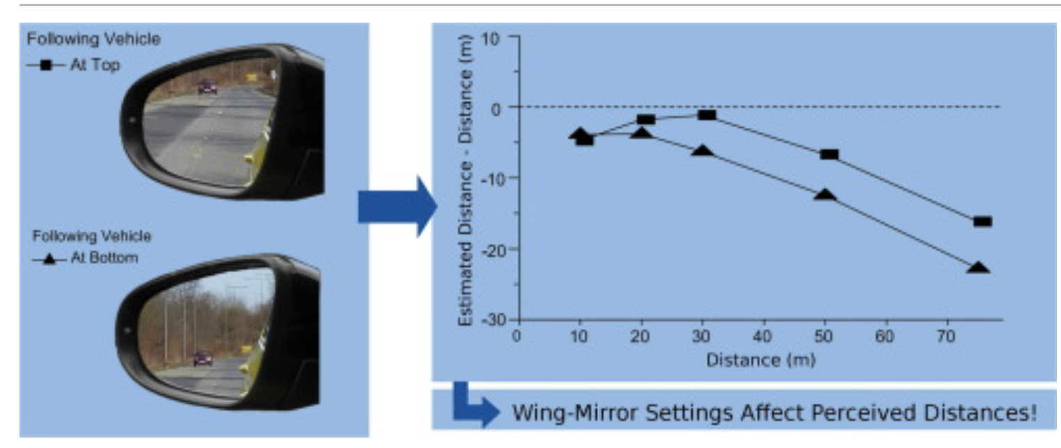

*Figure 11: Distance perceived correlation*

**Reference**

Jiang, X., et al. "Designing a User-Centric In-Car Interface: A Case Study on Rear-View Mirror Adjustment." *Transportation Research Part F: Traffic Psychology and Behaviour*, vol. 38, 2015, pp. 153-162, [https://www.sciencedirect.com/science/article/abs/pii/S1369847815001606.](https://www.sciencedirect.com/science/article/abs/pii/S1369847815001606)

## **5.10 Mouse cursor control with eye movement using OpenCV and machine learning**

This flowchart outlines the basic framework for an eye movement project using OpenCV. The overall process for eye and face detection will be similar to that of the current project. Excluding the cursor movement, various points can be leveraged to enhance the functionality of the current project. Key points are:

* Image Capturing
* Face Detection
* Morphological Process
* Eye Region Detection
* Eye Movement Classification
* Edge Detection

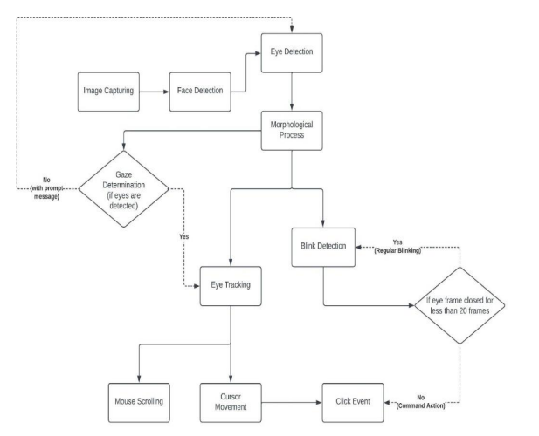

# 

# 

*Figure 12: Eye Movement Mouse Cursor Project Flowchart*

**Reference**

Li, L., Jin, Y., Wang, M., & Xu, Y. (2023). Mouse cursor control with eye movement using convolutional neural networks. *AIP Conference Proceedings*, 2857(1), 020023. <https://pubs-aip-org.libdb.njit.edu:8443/aip/acp/article/2857/1/020023/2907239/Mouse-cursor-control-with-eye-movement-using>

# **6.0 Hardware**

The hardware used for the project will consist of a microcontroller used to operate the rear-view mirror once it has processed the data from what the camera has gathered after locating the driver’s eye level. Furthermore, the mirror will be a part of a housing unit that contains two actuators that are stored in their own rotating gear that raises and lowers with the assistance of two 6V DC motors. The actuators are used to adjust the pitch and yaw of the mirror to pan either up or down and left or right, essentially acting similar to that of a powered side mirror. The components in the housing unit are connected to the microcontroller which will automatically adjust the mirror with the processed information gathered from the camera that is attached to the bottom of the mirror. In addition to the automatic systems there are also manual controls to make additional micro adjustments, if necessary, through the control of a directional pad.



*Figure 13: Top Level Block Diagram*

The first section of the top level block diagram focuses on the camera as once power is provided to the microcontroller it’ll activate the camera to then detect the eye level of the driver provided by the eye tracking software to gather the data. For the next block, the microcontroller then processes the data to then be sent to the motor and ball joint to make adjustments in the third block. Where it’ll make micro adjustments to offer the best angle for the driver to see out the back windshield. The final block focuses on the final adjustments needed to be made for the best view out the rear windshield for the driver.

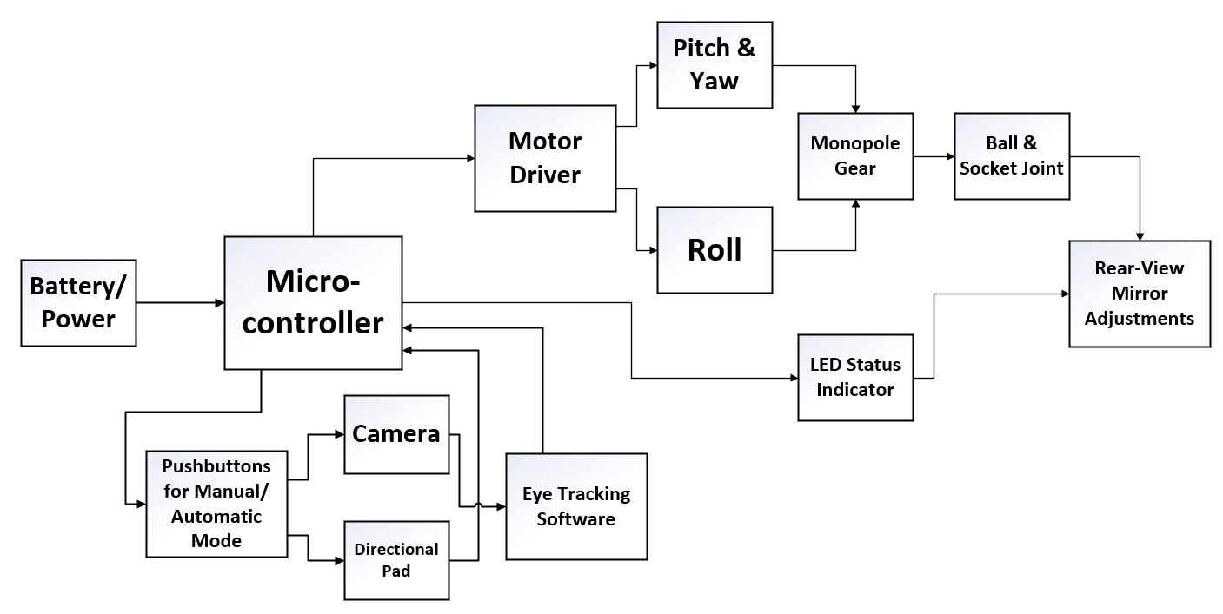

*Figure 14: 2nd Level Block Diagram*

The first section of the second level block diagram is where the power is sourced either from an adaptor or battery for the prototype phase or from the battery of a motor vehicle for a fully functional product. The next section is the microcontroller where the data is retrieved from the camera and processed and will then sent to the motors and ball & socket joint to adjust the rear-view mirror. Moving down to the next block is the sliding switch, which allows the driver to adjust the rear-view mirror either by automatic adjustment via the camera and eye tracking software or by using manual adjustment with the direction pad. The eye tracking software block focuses on locating the eye level of the driver to then send that information for the microcontroller to process and subsequently telling the DC motors to adjust accordingly. The motor driver block is the housing unit where the motors and ball & sockets will be housed and operating in. The motor block focuses on the DC motors used to raise the actuators used to control the pitch and yaw of the rear-view mirror, in addition the actuators are held inside gears and will rotate up and down to control the pitch and yaw. There will potentially be an additional DC motor to control the roll or z-axis for the rear-view mirror. The ball & socket joint block focuses on movement for the rear-view mirror when attached to the housing unit allowing for smoother movement when the driver or micro controller is adjusting it. The rear-view mirror adjustment block focuses on the micro adjustments made to the rear-view mirror offering the driver a better viewing angle out of the rear windshield. The LED status indicator block is the small pilot light used as indication for the driver, showing that automatic adjustments are being made once the power has been turned on for the microcontroller.

# **7.0 Software**

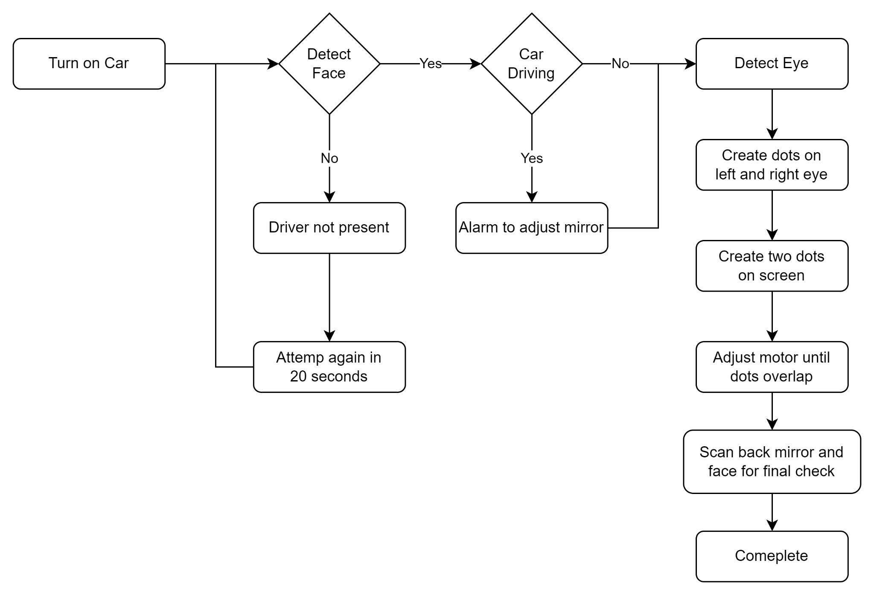

*Figure 15: Flow chart (Software)*

Using OpenCV and Python, the Raspberry Pi will interface with a camera to analyze the driver’s face in real-time. Upon detecting the driver, the system will confirm their presence in the vehicle and initiate the rear-view mirror adjustment process. If the driver’s face is not recognized, the system will assume conditions such as a remote start and wait 10 seconds before restarting the detection process.

Once the driver's face is recognized, the system will monitor for any attempts to drive before the adjustment is complete. If the driver tries to move the vehicle, an alert will notify them to wait until the adjustment is finished. The system will draw dots on each of the driver’s eyes and create two additional dots on the camera screen, then adjust the motor to align the pairs of dots for the optimal angle. Once the dots are aligned, it will do a final calculation based on the head position and the back glass of the car. After the process is complete, the mirror will be successfully adjusted, indicating that the driver is ready and safe to drive.

# **8.0 Project Plan**

## **8.1 Gantt Chart**

The Gantt chart shows the progress on tasks assigned to each team member as time moves forward, and what should be accomplished by each set date. Sections within the Gantt chart include the initiation, prototype, and execution phases, as well as testing and validation. For each section has been included the tasks that should be completed, members assigned to, percentage of progress, start date and end date.

### **8.1.1 Purpose**

The purpose of the Gantt chart in the project is to track the project progress, timeline, deadlines, and key milestones. Based on those milestones, parts of the project can be accelerated, modified, and/or removed where necessary.

### **8.1.2 Key components**

The key components or parts of a Gantt chart are milestones, dates, percentage of progress, start date, end date, name of the team members doing each task.

### **8.1.3 Advantage**

The purpose of a Gantt chart is to track the progress of the project for project management purposes.

### **8.1.4 Template**

Microsoft offers free templates that make it easy to create and customize Gantt charts in Excel. These templates provide a simple way to visualize project timelines and can be tailored to meet specific project needs.

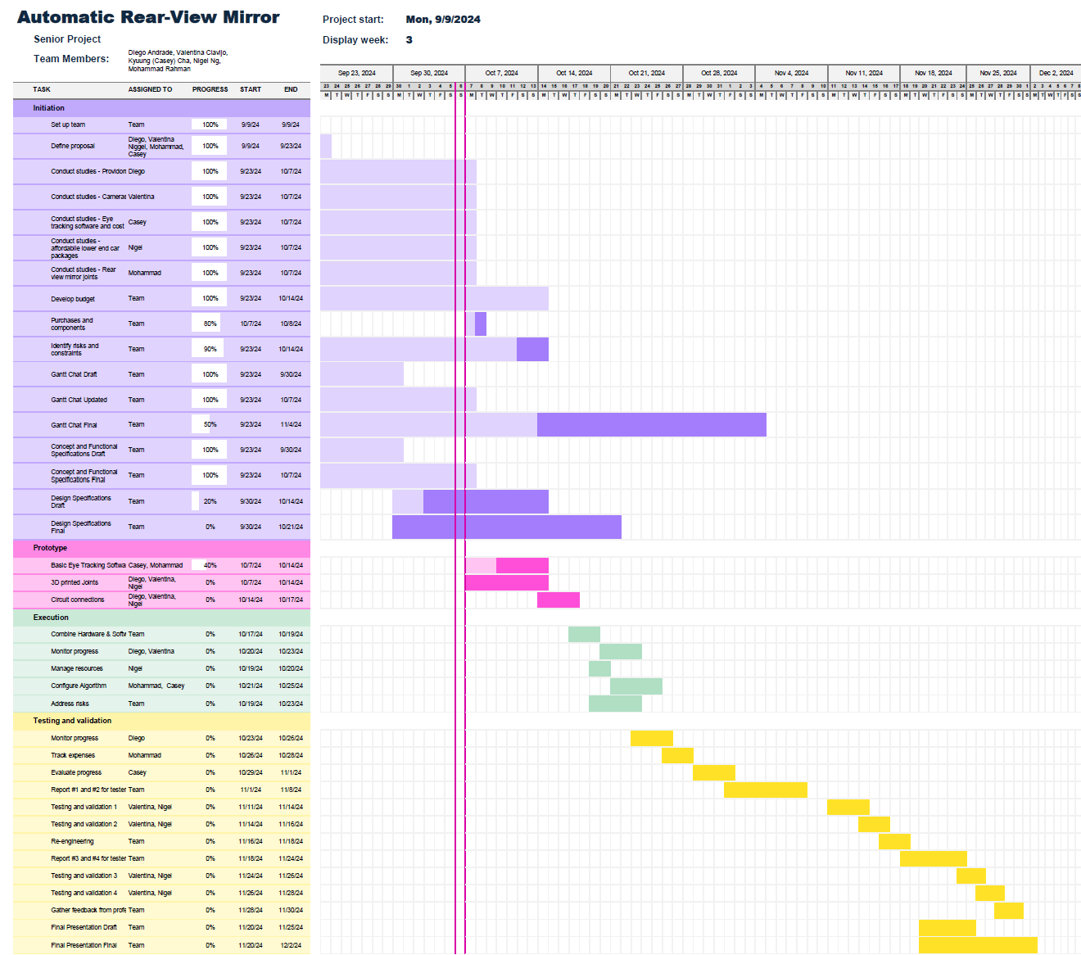

*Figure 16: Gantt Chart Automatic Rear-View Mirror*

## **8.2 Work Breakdown Structure**

Team meetings provided members time to discuss what steps needed to be accomplished and where team members were needing assistance. As the semester progresses, the team will meet at various locations and scheduled time to build and test the prototype. Before concluding the meeting, tasks are assigned to members to progress forward and allow for clear instructions to be understood and followed. These discussions and assignments help maintain focus and ensure the project stays on track.

Table #4: Work Breakdown Structure

| **Tasks** | **Responsibility** |
| --- | --- |
| Research | Team members were assigned research topics, Hardware, software, boards, motors, and statistics. All research was used and presented as reference. |
| Budget | Budget was calculated based on the needs of the project. All the items listed were needed to present a working prototype. Meetings were held and attended by each member in the library to discuss parts and software. |
| Gantt chart | In order to manage the project Valentina had to create and organize a gantt chart to keep track of timeline, progress, and deadlines. Valentina used a smart spreadsheet and broke down all the important dates, tasks, reports, execution and testing requirements. |
| Concept and functional specifications Document | Team members had to compile all their research to complete specific functions and concepts. Flowcharts and drawings were created for the software and hardware integration. Diego provided support and assisted team members where parts of the project became more complex. |
| Purchases and components | All components have been purchased. 3D printed joints are in development and being tested. |
| Software/Hardware | Casey is working on the software. It is 40% complete and is in the testing phase for the eye-tracking side of the software. |

## **8.3 Four Hardware/Software Deliverables**

1. Pupil position detecting OpenCV Software:

* The software will detect the eyes position to provide a more accurate adjustment based on where it's looking.

1. Ball Joint Motor that can adjust X Y Z axis:

* To move it in 3 degrees of freedom more precisely and smoothly

1. Pi / Microcontroller that can bridge the software and hardware

* The microcontroller using its I/O will process the data taken using the camera for eye tracking and use the software to move the motors and adjust the mirror.

1. Algorithm to calculate the adjustment angle required based on the pupil coordinates

* The algorithm will catch the position of the pupil and map it for adjustment angles.

## **8.4 Possible Problems**

### **8.4.1 Compatibility Issue with camera, microcontroller, and the motor**

The compatibility of the camera, microcontroller, and motor must be verified before taken into development. The solution to ensure seamless integration, both the camera and microcontroller will be updated with the latest software versions.

### **8.4.2 Software not being able to detect coordinates properly due to interference**

Using OpenCV, the camera will detect the left and right eyes, marking them with dots on the screen. In addition to the eye dots, two static dots will be displayed on the screen. The algorithm will calculate the distance between the detected eye dots and the static screen dots. Based on this calculation, the camera will adjust its position to ensure that the dots overlap perfectly. Because of this, the precision for the eye tracking is essential, as misalignment can lead to incorrect adjustment which defeats the purpose of the overall project. To resolve this, the most well tested and advanced eye tracking model should be utilized.

# **9.0 Appendices**

## **9.1 Acronyms and Definitions**

ABENICS (Active Ball Joint Mechanism)- is a gear-based system that allows for three rotational degrees of freedom (3 RDoF) without slippage (Abe et al., 2021).

D-pad -(short for directional pad) is a flat, cross-shaped control found on most game controllers and also on cars.

Microcontroller - it is a compact integrated circuit designed to govern a specific operation in an embedded system (Rouse, n.d).

Eye Tracking - A kind of technology that observes and measures eye movements, pupil dilation, point of gaze, etc. (Hotjar, n.d).

## 

## **9.2 Parts list**

**Table #5: Parts List**

| **Component** | **Part Number** | **Description** | **Quantity** | **Cost Per Unit** | **Total Cost** |
| --- | --- | --- | --- | --- | --- |
| Raspberry Pi | 4 model B | [Pi 4 4GB Board Only](https://www.canakit.com/raspberry-pi-4-4gb.html?cid=usd&src=raspberrypi) | 1 | $55.00 | $55.00 |
| Motor | DC 12V 550 RPM | [Greartisan DC 12V 550 RPM Gear Motor High Torque Electric Micro Speed Reduction Geared Motor Centric Output Shaft 37mm Diameter Gearbox](https://www.amazon.com/Greartisan-Electric-Reduction-Centric-Diameter/dp/B072R5G5GR/ref=sr_1_6?dib=eyJ2IjoiMSJ9.DVWk5pLyQ_dqDp13O4lPtXmWJI-1PIDOGCXkdHtBmk8kIkbhaTpLe9H5dfid5uMbi3GzMdo-mdpM9U8yt_FHOFVe13uaeaJHaaeGRUdknU6j9w-tYt_hyOkCkRMPB_9s2DW1F7Xw3hzCqTFcXVQwW-q_n5dNwxl1b7ungHc3w41trYXV6S-P7GOEoIbjEFxIls6oe45XqJGevlB48n9pdQJbXKD7HJbBAeXC8EXyC2a_fwVbRS_tMMk0esKfpy7AN52JDr3jkJSRhn0bDPy_KWWrOlS1TwtlI6wbIr6yOF4.R0z_GKXggYmb6AjWPk86apT7ntOMUQBSAj7IEeFEk3U&dib_tag=se&keywords=high%2Btorque%2Bdc%2Bmotor&qid=1728144444&sr=8-6&th=1) | 4 | $14.99 | $59.96 |
| Directional Pad | Joystick Raspberry Pi | [2 Pack USB Wired Controller for NES Games, PC USB Controller Retro Gamepad Joystick Raspberry Pi Gamepad Controller for Windows PC Mac Linux RetroPie NES Emulators](https://www.amazon.com/Controller-suily-Joystick-RetroPie-Emulators/dp/B07M7SYX11/ref=sr_1_6?dib=eyJ2IjoiMSJ9.p45G3wTl2KtpvsqDvmgzbWrNVH_F503IiCs9eXdirVP0blaJUCWLAUxiZOjGiCfa5aonEMM0qXBrCgRJWHfCKC_Xz3pNPfI2RGinE0zWuUcnuN_xXtAR1IUwkTsup8qBuUWFJ1WXnOavcVjily8SmnHagxl7i3RFBKx1pE_H0sO-EZD8ikhddLPx9DYA_n0F9xNMsf_7j2N2WkSKe_tM4jCqsvqj-2ttw2JjHMp6xF0.aiwzyNT-ZJPuM-WylsB9jCHWFe8sQS0CGmr2YK91s4M&dib_tag=se&keywords=raspberry+pi+controller&qid=1728144645&sr=8-6) | 2 | $7.99 | $14.99 |
| ABENICS Joint | N/A | 3D Printed Joint | 4 hours | $1.00/hour | $4.00 |
| Pack of Pilot Lights | 3mm LED Lights | [250pcs (5 Colors x 50pcs) 3mm LED Light Emitting Diode Lamp Diffused Assorted Kit (White Red Green Blue Yellow)](https://www.amazon.com/250pcs-colors-Emitting-Diffused-Assorted/dp/B00XT0P1VQ/ref=sr_1_18?crid=2XLLFMJNHKY1B&dib=eyJ2IjoiMSJ9.2P3BrZMmEVhytHhxsQcAj_6jj7TruwK-Te391ARO9tUJjbSQa-ZeEqpvL4rfOIuukvJvMZMVEdpZrmUhBlYmRzPtgc8SC4tKykfZEniG44cvmQYsYZFF3H9L1T-1VMEZJz43XtVN6_TFXwvh3DU25lugjP7Ilm7Q4limoH78kYg0g2rEiOv-zSu-3-KXzXyRdcScMBD8YZsU3MQ8U11IoPkkk3FN-sR0OtJL1YG_j_ee1CSNXHcobimV8Bt4uQ6UCVeVAVFDZe_jCLgyj0RTPx2m7Cr18RqHsi_F075ejLc.4YvMj59SdRUDz6zRtJKaU3UbQUwjtO3bL3DAlyOdW44&dib_tag=se&keywords=led+kit&qid=1728145091&s=industrial&sprefix=led%2Cindustrial%2C66&sr=1-18) | 1 | $4.99 | $4.99 |
| Camera | RPI-CAM-V2 | [Raspberry Pi Camera Module V2-8 Megapixel,1080p (RPI-CAM-V2)](https://www.amazon.com/Raspberry-Pi-Camera-Module-Megapixel/dp/B01ER2SKFS/ref=sr_1_1?crid=1TB0DT502CDX1&dib=eyJ2IjoiMSJ9.xxu7QU8kN0VD6CKF0tUrJ0BN31Cb8_GMvr-0wTCnpDHijftlcdY2KC-tUK3DrRJLjiw8wk_LMNs_gZHer0qb8aZa9arPMU4WfuGGEMAUQBCnKiTBQooa9TjDpkiVVnxsN9lSA5v7xUYYqkOY-3Xsq1b6TjuZANabL3nA3DOZ4a0W0dbxlRLk6_QPcyhAUopT_fQKO3wXFd3FFRiKF95CqaCCpd2OdrwfAQBHE62xOzA.0mVfkzD6A7mz3PryM6zITHBX5JXPMppf3R06BB4czZ0&dib_tag=se&keywords=raspberry+pi+camera+v2&qid=1728145246&sprefix=raspberry+pi+ca%2Caps%2C67&sr=8-1) | 2 | $12.79 | $25.58 |
| Breadboard | 7545924028 | [breadboard Set Prototype Board - 6 PCS 400 Pin Solderless Board Kit for Raspberry pi and Arduino Project](https://www.amazon.com/DEYUE-breadboard-Set-Prototype-Board/dp/B07LFD4LT6/ref=sr_1_8?dib=eyJ2IjoiMSJ9.BTT8MNHPlv4K77wqKb52ByAXtg73bl6b9fTl1eFcy1D8prdR062SGqtyeIR2UOoK2hp808_Lk9H1HYSgB5TDRdoGQyqpwtz_4JZFhLOr-Yp8EH_kif8sqrSsQs5n3-P2PGEYnamyULesr6xUb4l9mt48tVWN10nTU3bE-XRPeEpgOF55OVWfWS0Snkat-YmJqUk2sZgtsTeMs9VGDgBmsZG7Bb1dGSxzefK914XMyDE.x0O9ij7lUC5q6phgaDEfkwsGBBHJjQ1xGBM2baYDdQg&dib_tag=se&keywords=breadboard&qid=1728265142&sr=8-8) | 1 pack of 3 | $7.99 | $7.99 |
| Rear-view mirror | BT-4MG9-2IM9 | [Kitbest Rear View Mirror, Universal 11.4 Inch Interior Clip On Panoramic Rearview Mirror, Wide Angle Rear View Mirror, Convex Car Mirror to Reduce Blind Spot Effectively for Car SUV Trucks – Clear](https://www.amazon.com/Kitbest-Mirror-Rearview-Interior-Effectively/dp/B07567QLTX/ref=sr_1_4?dib=eyJ2IjoiMSJ9.zykBeeSH72nzLDVhGBoiO-PUmrP6F0AfOCore398zfQaGnhNhdMvxUAMkEFFMKssAxRatUH_0wQzrcqNW9BccdAOH_ALd4_aURDRUqB4BKIZs3y_YsgoKTsOBNpI6IyjADEKe5G8AGifV_e_XmrsN12z1u-jsE69F5o8qBlUhlarJfhXUjmPIuNKycWqQE6KRIkRmgays4egYtdnInP6x-a2-hzyaLnAbthqdmbUTzKnq0nnNxdMRk1TTCFDtuA_D6NMA2WNyFDmwKa2yjdNAdaDU6a1BGmwNwDOQyMCDSc.4PDzuee97_rqizbHAjn4WC0Y0xqsJ-cLp8fkHvzYY8k&dib_tag=se&keywords=rear%2Bview%2Bmirror%2Bglass%2Breplacement&qid=1728265030&s=automotive&sr=1-4&th=1) | 2 | $9.99 | $19.98 |
| Wires | EL-CP-004 | [ELEGOO 120pcs Multicolored Dupont Wire 40pin Male to Female, 40pin Male to Male, 40pin Female to Female Breadboard Jumper Ribbon Cables Kit Compatible with Arduino Projects](https://www.amazon.com/Elegoo-EL-CP-004-Multicolored-Breadboard-arduino/dp/B01EV70C78/ref=sr_1_4?crid=K2CVJNLOIJ2M&dib=eyJ2IjoiMSJ9._--XVj7sIVPW5Oud9uWtGSHZ162tO6_pDczMCIn5t6CZlKUDdTVqkeNumVJlpAQyaJUxzeIkvt5UFjW9hjRszFoUQTnVlzSjBjBGZ7nZLF4AwOAfYHOI2NxsMUB0Fr2GEt7WidpQvafRB8giJ6wqH-zeUpfRKqXlkHLpAk8ImFa-n0aTAB_maLD5FIzyRIB9NQGU7hCgcqVcGwcBHkxVBs--E7BnlDoFYpVuhib7MEs.VIc8m44ovEhG1srI0NDf_cCPAvjoiWPNqgU8q5L1SQs&dib_tag=se&keywords=breadboard+wires&qid=1728265242&sprefix=breadboard+wires%2Caps%2C83&sr=8-4) | 1 | $6.98 | $6.98 |
| **TOTAL COSTS** | | | | | **$199.47** |

# 

# **References**

Allied Market Research. (2024). *Car sharing market by service type, vehicle type, and application: Global opportunity analysis and industry forecast, 2023-2032*.<https://www.alliedmarketresearch.com/car-sharing-market-A07125>

National Household Travel Survey. (2022). *2022 National Household Travel Survey summary of travel trends*. Oak Ridge National Laboratory.<https://nhts.ornl.gov/assets/2022/pub/2022_NHTS_Summary_Travel_Trends.pdf>

Nationwide Disability Representatives. (n.d.). *Avoid blind spot collisions.*<https://www.nationwidedisabilityrepresentatives.com/blog/avoid-blind-spot-collisions/#:~:text=According%20to%20the%20National%20Highway,year%20in%20the%20United%20States>

European Patent Office, Method for controlling automatically for car rear view mirror employing driver's eye location and apparatus thereof

. (2020). *Patent KR102135305B1: Description.*<https://worldwide.espacenet.com/publicationDetails/description?CC=KR&NR=102135305B1&KC=B1&FT=D&ND=&date=20200717&DB=EPODOC&locale=>

Karvir, S. (2023). Automatic Adjustable Rear-View Mirror Using Servo Motor and Arduino for Bikes. *International Journal for Research in Applied Science and Engineering Technology*. <https://doi.org/10.22214/ijraset.2023.57169>

Rota, F., & Stefano, L. (2017). Automatically adjustable rear mirror based on computer vision. *2017 International Conference of Electrical and Electronic Technologies for Automotive*, 1-7. <https://doi.org/10.23919/eeta.2017.7993218>

Blincoe, L., Miller, T., Wang, J.-S., Swedler, D., Coughlin, T., Lawrence, B., Guo, F., Klauer, S., & Dingus, T. (2023, February). *The economic and societal impact of motor vehicle crashes, 2019 (Revised)* (Report No. DOT HS 813 403). National Highway Traffic Safety Administration. [The Economic and Societal Impact of Motor Vehicle Crashes, 2019 (Revised) (dot.gov)](https://crashstats.nhtsa.dot.gov/Api/Public/ViewPublication/813403.pdf)

*Safety first: car crashes, innovation, and why federal policy should prioritize adoption of existing technologies to save lives - CR Advocacy*. (2020, June 28). CR Advocacy. <https://advocacy.consumerreports.org/research/cr-safety-first-car-crashes-innovation-federal-policy-study/>

Abe, K., Tadakuma, K., & Tadakuma, R. (2021). ABENICS: Active ball joint mechanism with three-DoF based on spherical gear meshings. IEEE Transactions on Robotics. Retrieved from <https://doi.org/10.1109/TRO.2021.3070124>

Rouse, M. (n.d.). Microcontroller. TechTarget IoT Agenda. Retrieved October 3, 2024, from<https://www.techtarget.com/iotagenda/definition/microcontroller>

Hotjar. (n.d.). Eye tracking. Hotjar Conversion Rate Optimization Glossary. Retrieved October 3, 2024, from <https://www.hotjar.com/conversion-rate-optimization/glossary/eye-tracking/>

M. Shawky (2020), "Factors affecting lane change crashes", IATSS Res., vol. 44, no. 2, pp. 155-161, Jul. 2020. <https://www.sciencedirect.com/science/article/pii/S0386111219300020>

Valentine, Ashlee (2024); Smith, Kelly Anne (2024). Car Ownership Statistics 2024**,**

Forbes Advisor, March 2024. <https://www.forbes.com/advisor/car-insurance/car-ownership-statistics/>

Survey/Program: American Community Survey Year: 2022 Estimates: 5-Year   
Table ID: DP04 Source: [U.S. Census Bureau, 2018-2022 American Community Survey 5-Year Estimates](https://data.census.gov/table/ACSDP5Y2022.DP04?moe=true)

https://www.sciencedirect.com/science/article/abs/pii/S1369847815001606

1. [Allied Market Research](https://www.alliedmarketresearch.com/car-sharing-market-A07125)
2. [National Household Travel Survey](https://nhts.ornl.gov/assets/2022/pub/2022_NHTS_Summary_Travel_Trends.pdf)
3. [National Household Travel Survey](https://www.nationwidedisabilityrepresentatives.com/blog/avoid-blind-spot-collisions/#:~:text=According%20to%20the%20National%20Highway,year%20in%20the%20United%20States.)
4. [National Highway Traffic Safety Administration](https://crashstats.nhtsa.dot.gov/Api/Public/ViewPublication/813403.pdf)
5. [Consumer Reports](https://advocacy.consumerreports.org/wp-content/uploads/2020/06/CR-Safety-First-White-Paper-June-2020.pdf)
6. [ABENICS](https://ieeexplore.ieee.org/document/9415699)
7. [Science Direct](https://www.sciencedirect.com/science/article/pii/S0386111219300020#ab0005)
8. [Forbes Advisor](https://www.forbes.com/advisor/car-insurance/car-ownership-statistics/#cost_to_own_a_car_section)